International Registries, Inc.

OWS Maintenance Documentation

Applications Release: OWS/EDQ

Author: OFSAA consulting team

Creation Date: 02/17/2019

Last Updated: 3/19/2019

Project ID:

File URL: <Share folder location>

Document Version: 1.3

Status: Completed

Template Version:

Document Control

Contributors

|  |  |  |
| --- | --- | --- |
| Name | Role | Content Contribution |
| Suraj Kumar | Subject Matter Expert | Jobs, Logs, etc |
|  |  |  |
|  |  |  |
|  |  |  |

Change Record

|  |  |  |  |
| --- | --- | --- | --- |
| Date | Name | Version | Change Reference |
| 18-Feb-2019 | Suraj Kumar | Draft 1 | No Previous Document |
| 7-March-2019 | Suraj Kumar | 1.1 | Updated the start and stop domain server details with right command n server details with right command. Removed the Heap size increment details |
| 15-March-2019 | Suraj Kumar | 1.2 | Updated the startNodeManager.sh and section 9-11 point. |
| 17-March-2019 | Suraj Kumar | 1.3 | Updated the section 2.5 for deleting the Alerts from Watchlist Screening UI |
|  |  |  |  |
|  |  |  |  |
|  |  |  |  |
|  |  |  |  |

Document References

|  |  |  |  |
| --- | --- | --- | --- |
| Title | Author | Location |  |
|  |  |  |  |
|  |  |  |  |
|  |  |  |  |
|  |  |  |  |

Reviewers and Approvers

Reviewers

|  |  |  |  |  |  |
| --- | --- | --- | --- | --- | --- |
| Name | Role | Status | Comments | Version Reviewed | Date |
| Oracle Team |  |  |  |  |  |
| Tony Suazo |  |  |  |  |  |
|  |  |  |  |  |  |
|  |  |  |  |  |  |
|  |  |  |  |  |  |

Approvers

|  |  |  |  |  |  |
| --- | --- | --- | --- | --- | --- |
| Name | Role | Status | Comments | Version Reviewed | Date |
| Oracle Team |  |  |  |  |  |
| Tony Suazo |  |  |  |  |  |
|  |  |  |  |  |  |
|  |  |  |  |  |  |
|  |  |  |  |  |  |
|  |  |  |  |  |  |

Table of Contents

1. Glossary & Legends 5

1.1 Glossary 5

2. Overview 10

2.1 Start the Application Server and Domain Server: 10

2.2 Stop the Domain Server and Application Server: 12

2.3 EDQ Jobs & Data Landing Area: 12

World Check holding place: 12

RUN Profile location: 12

Run the jobs 13

To load the reference file WC (World Check) 13

To run the real-time job 13

2.4 Log-file location: 15

Log-file location to check the log “main0.log” 15

Log-file location to check the log “edq_server1-diagnostic.log” & “edq_server1.log” 15

Install file location: 16

EDQ Local home location: 16

Error Log: 16

Error while initiating the download of WC data: 16

Solution: 16

The error comes for very first time and it will not repeat as the data will always be there. Make sure that you run “WC_Profiles” staging and then rerun the “Download, Prepare, Filter and Export All Lists” with “Run with profile” and select watchlist-management. 16

Tablespace Error: 17

Solution: 17

# Glossary & Legends

## Glossary

| Term | Definition |
| --- | --- |
| Alert | An alert is the smallest unit of review work used in Case Management. An alert usually represents a possible match between two records from different data sources. |
| Alert Key | The Alert Key, which is defined in the Case Source, specifies the way that records will be grouped together to form an alert. The Alert Key normally consists of the primary key fields from all input data streams used to generate alerts. |
| Attribute | An attribute in EDQ is used to describe a distinct item of information describing a record - for example, a Gender attribute might describe a Customer record. When working with data from a database source, the term attribute is synonymous with 'column'. |
| Attribute (Case Management) | Attributes are fields that are present in all cases and alerts. Attribute values can be set as part of the processing carried out by a transition, by a reception rule, or when a state expires. |
| Case | A case is a group of related alerts. The contents of a case are defined by the case key. |
| Case Key | The Case Key, which is defined in Case Source, specifies the way that alerts will be grouped together to form a case. Because a case is a group of related alerts, a Case Key is usually formed from a subset of the fields in the Alert Key. |
| Case Source | A Case Source must be defined for all match processors which use Case Management. The case source controls how the relationships generated bytch processors are used to create cases and alerts. |
| Data Interface | A Data Interface is a set of data attributes with data types that are used to define reusable processes with no specific bindings to source and/or target data sets. Data sets are mapped to and from Data Interfaces using Data Interface Mappings. |
| Data Interface Mapping | A Data Interface Mapping is used to map the attributes in a source of data to a Data Interface used to read data into a process, and/or to map a Data Interface used to write data out of a process to a target of data. |
| Data Store | A Data Store is a database or file used as either a source or target (or both) of data for EDQ. Data from a data store may be processed by EDQ. EDQ may also export data to a data store. |
| Dynamic Permission | Dynamic Permissions in Case Management are an extension to the EDQ user permissions. They are used to control which data can be accessed by which users. Dynamic Permissions are defined in Case Management Administration and can be associated with case sources, states and transitions. |
| Enrichment | As per Gartner definition: Enhancing the value of internally held data by appending related attributes from external sources (for example, consumer demographic attributes or geographic descriptors) |
| ETL | A standard industry acronym (Extract, Transform and Load). |
| Extended Attribute | Extended Attributes are custom fields that are present in cases and alerts. They are populated and processed in a similar way to attributes but are defined in a configuration file, flags.xml, which is found in the...\config\casemanagement directory. |
| Flag | A Flag is an attribute containing data used to describe other data. For instance, a flag attribute might store a Y or N value indicating whether or not another attribute is populated. |
| Flag Key | Flag Keys, which are defined in case sources specify data fields which are not part of the case key or the alert key, but whose contents are likely to be significant to a review decision. Changes to these fields may cause a case or alert to be re-raised for review in the Case Management system. |
| Generalized “cleansing” | As per the Gartner definition: Modification of data values to meet domain restrictions, integrity constraints or other business rules that define sufficient data quality for the organization |
| Issue | An issue is an item of intelligence discovered from the analysis of data using EDQ. An issue may also contain a follow-up action assigned to a specific user. |
| Job | A Job is the saved definition of a set of actions to be performed by an EDQ server. Jobs consist of multiple tasks and may be scheduled to run either at a given time or on a regular basis. Tasks include running external scripts, running snapshots, running processes, and exporting results to target databases or files. |
| Match Group | A Match Group is a group of records brought together by a match processor, where each record in the group must be matched to another record in the group by a relationship with a decision of Match. An advanced option on match processors also allows Review decisions to be considered when forming Match Groups. Match Groups are also used when merging output in a de-duplication, consolidation or enhancement match process - a single merged output record is created for each Match Group, from each of its constituent records. |
| Matching — Identification | As per Gartner definition: linking or merging related entries within or across sets of data |
| Monitoring | As per Gartner definition: Deployment of controls to ensure ongoing conformance of data to business rules that define data quality for the organization |
| Parameter | Parameters are defined as part of Workflows in Case Management. Parameters are populated by the match processor and are used to transfer additional information into the case and alert generation process. |
| Parsing | Parsing in EDQ is the application of user-specified business rules and artificial intelligence in order to understand and validate any type of data en masse, and, if required, improve its structure in order to make it fit for purpose. |
| Parsing and standardization | As per Gartner definition: Decomposition of text fields into component parts and formatting of values into consistent layouts based on industry standards, local standards (for example, postal authority standards for address data) user-defined business rules, and knowledge bases of values and patterns |
| Process | A process is a configured chain of processors, used to profile, analyze, transform, match or merge data. A process may be executed or scheduled either on its own or part of a larger Job. |
| Processor | A processor is a tool used to construct data quality processes. There are a number of types of the processor for different tasks - profiling, audit, transformation, match, text analysis, maths, writers, and custom processors. |
| Profiling | Analysis of data to capture statistics (metadata) that provide insight into the quality of the data and aid in the identification of data quality issues |
| Project Note | A Project Note is a note associated with a project, e.g. an announcement to all users about the project. A note may contain one or more file attachments, e.g. a project plan. |
| Reception Rule | Reception Rules are used to define the way a new case or alert will be processed when it first enters a Workflow. Reception Rules consist of a set of actions which will all be considered for application to the incoming event. Each action can specify a conditional expression which will be evaluated for each case or alert; the action will only be applied to that alert if the expression evaluates to 'true'. |
| Record | A record in EDQ is a structured collection of attribute values. When working with database data sources, the term record is synonymous with 'row'. When working with a real-time message feed, the term record means the part of an inbound transaction (e.g. 'Add customer') that is understood to describe a single record. |
| Reference Data | Reference Data is data that is used for the validation or transformation of working data in processors. Examples of Reference Data include lists of valid and invalid values, standardization maps, and character maps (e.g. used to generate patterns from data values). Reference Data may also be a view of Staged or External Data. |
| Results Book | A Results Book is a portfolio of the most important results in a data quality project. Results Books may be viewed in Director and exported externally as part of the delivery of results. |
| Review Group | A Review Group is a group of records formed by a match processor, where each record in the group must be related to another record in the group by a relationship with a decision of either Match or Review. A Review Group may be broken up into several Match Groups, by making manual No Match decisions on its Review relationships. |
| Score Threshold or Weight | Between 0 and 100.  Specifies the score above which the matched records are returned by the matching field or fields or service. Records equal to or greater than the score are considered as matches and the records with scores less than the threshold are rejected. |
| Snapshot | A snapshot is a copy of data in EDQ's repository. A snapshot is a type of Staged Data. A snapshot configuration stores the way in which data is copied from a data store. |
| Staged Data | Staged Data is a general term for a type of data table that is held in the repository. There are two types of Staged Data - snapshots (copies of source data) and written data (data written by Writer processors). Either may be read at the beginning of processes. Written data may be exported externally. |
| State | States, along with transitions, are the building blocks of workflows. The state of an alert or a case indicates its position in the workflow. |
| Token | A Token is a piece of data that is recognized as a unit by the Parse processor using rules. A given data value may consist of one or many tokens. A token may be recognized using either syntactic or semantic analysis of the data. |
| Transition | Transitions define the ways a case or alert can enter a new state. A transition specifies the new state for the case or alert, plus any changes to attribute or extended attribute values that should occur at the same time. |
| Workflow | A workflow consists of a series of states, linked by transitions. Together, these form a network which represents a valid case or alert lifecycle. A workflow may also define parameters, which can carry additional information from the match processor, and reception rules, which specify the processing, carried out on a new case or alert when it is first created. |

# Overview

The EDQ/OWS Maintenance jobs are predefined jobs which needs to runs to make the real-time web service working. It also provides the basics of debugging the issues looking into the logs file, and identifying the issues facing at UI end or at back-end.

## Start the Application Server and Domain Server:

1. Open putty or Xserver client (I have used MobaXterm freeware tools)
2. Login with your credentials and permission to go to /iridrows/app01/oracle

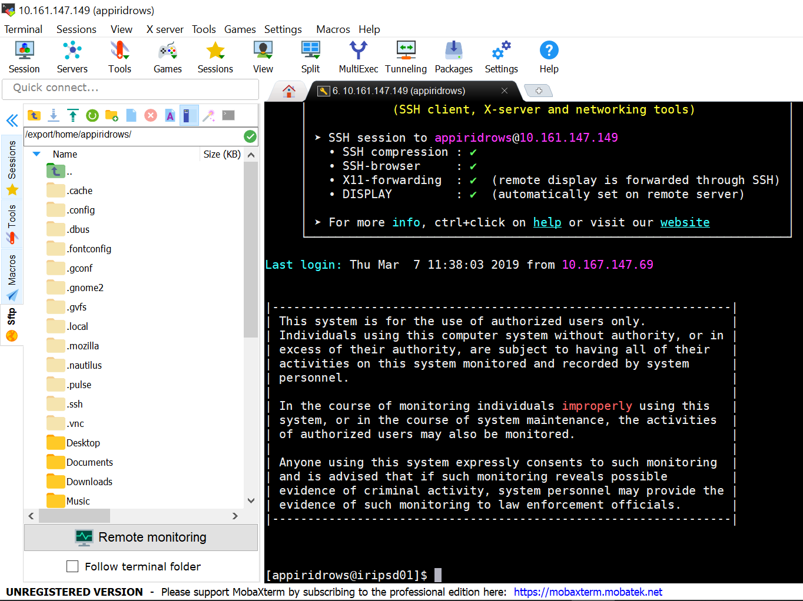

1. Please go to the location:
2. Non-Prod: /iridrows/app01/oracle/middleware/oracle_home/user_projects/domains/edqdr_domain/bin

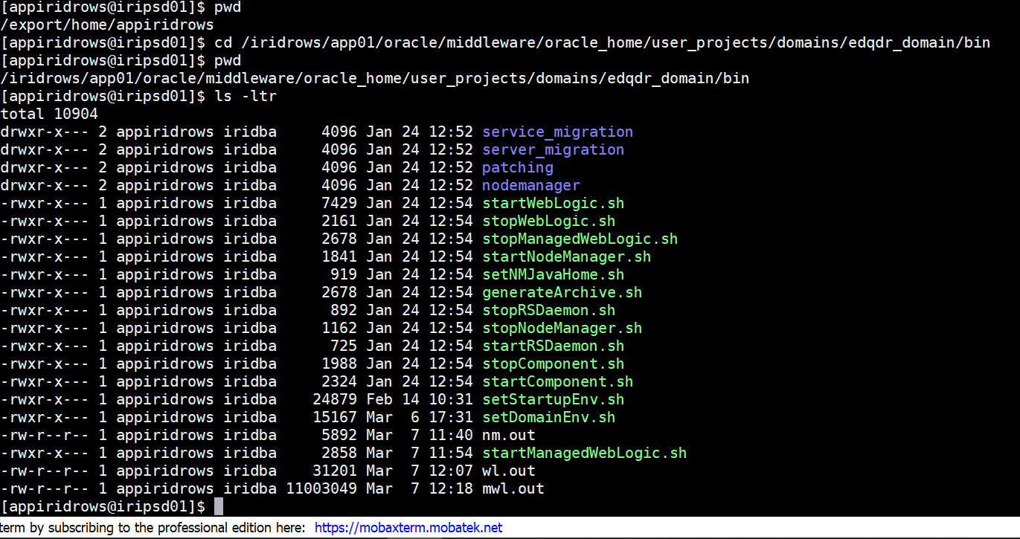

1. Prod

/iripows/app01/oracle/middleware/oracle_home/user_projects/domains/edqp_domain/bin

1. Please follow the step to start the server:
2. Please make sure that NodeManager.sh is running. The command to start the NodeManager.sh is to go to the directory: /iridrows/app01/oracle/middleware/oracle_home/user_projects/domains/edqdr_domain/bin

nohup./startNodeManager.sh >nm.out&

1. Application server startup, execute the command: nohup ./startWebLogic.sh > wl.out&
   1. The above command will execute the job and cursor will be available to the user
   2. Using tail command will provide the details the steps getting executed by step 2.

tail -f wl.out

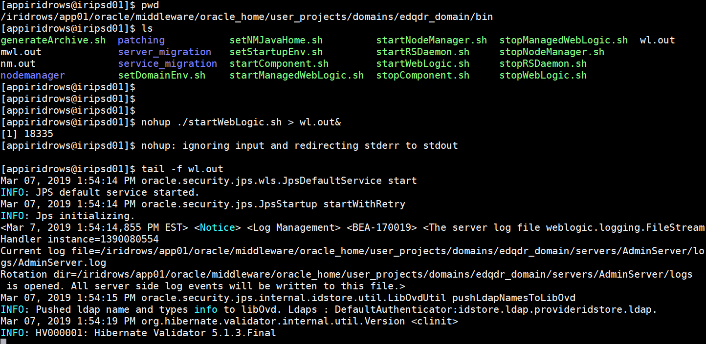

* 1. Or ./ startWebLogic.sh this will let the steps complete and cursor will be occupied post start and user will not able to use the cursor. To avoid this use the command provided in step 2

1. Note: Above command with use the state persistence so If the “AdminServer(admin)”and domain server “edq_server1” are running okay before you stop the WeLogic server using given command “./stopWebLogic.sh , it will by default start both Admin and Domain Server
2. Then use WebLogic console and start the edq_server1 from console, after refreshing you will see up and running.
3. To start Domain Server (edq_server1) from command prompt you need to run the command:

nohup ./startManagedWebLogic.sh edq_server1 > mwl.out& (please make sure that startManagedWebLogic.sh file should have the user name password value in it. Right now all the value is set in the entire application box)

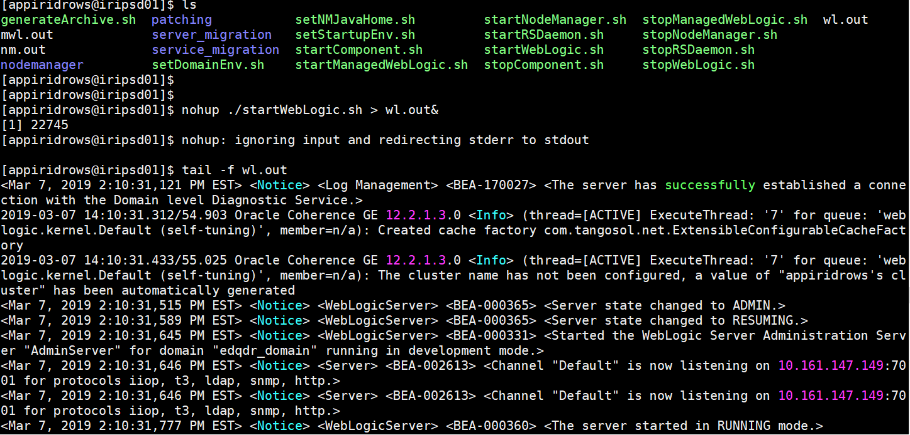

1. Using tail –f mwl.out command will provide you the log access to all the activities for number 7 steps.
2. The above command should only be used in case the domain server (edq_server1) is not started using the given command at 5 (nohup ./startWebLogic.sh > wl.out&)

## Stop the Domain Server and Application Server:

1. Please go to the location:
2. Non-Prod:

/iridrows/app01/oracle/middleware/oracle_home/user_projects/domains/edqdr_domain/bin

1. Prod:

/iripows/app01/oracle/middleware/oracle_home/user_projects/domains/edqp_domain/bin

To individually stopping the servers

* 1. ./ stopManagedWebLogic.sh edq_server1
  2. ./stopWebLogic.sh

1. 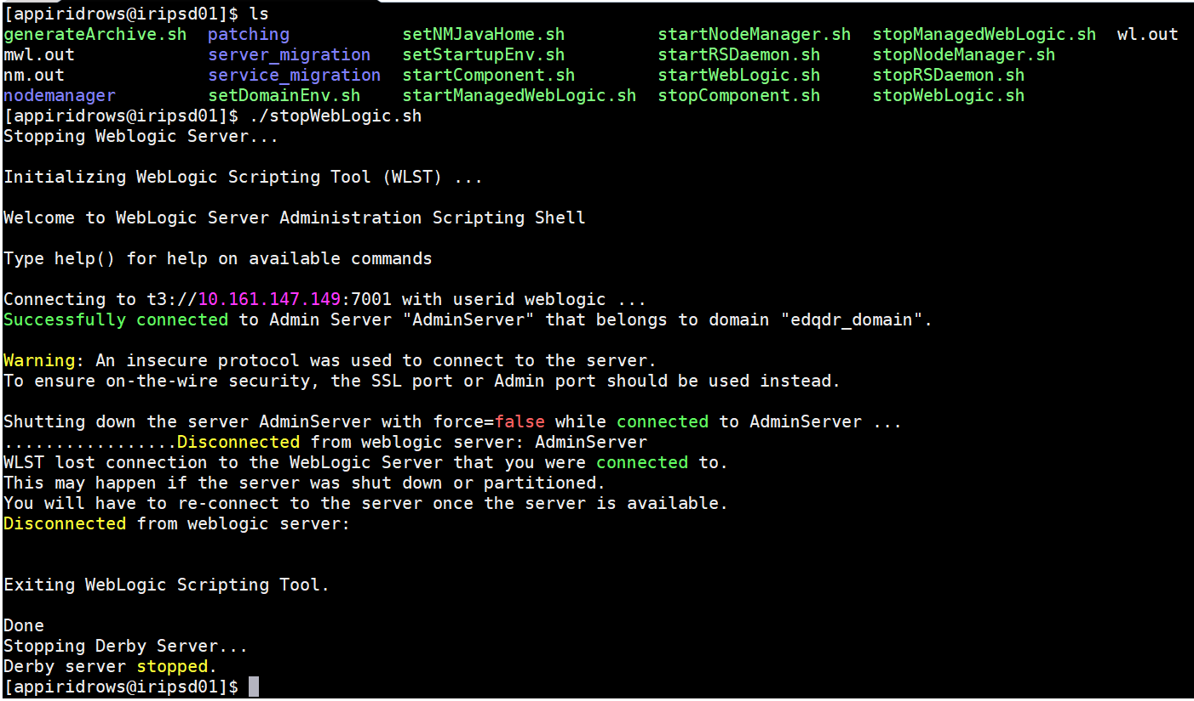
2. If for some reason you are facing an error for edq_serve1 is not starting, please check whether the port 8001 is running or not. We have observed during the load break test that there are multiple threads got stuck and not able to stop from command prompt using 3b or 3a above as given.
   1. To check the port occupied or not, please use the below command:
   2. lsof -t -i:8001 You will be responded with PID (port id) using this PID, kill the process which is stuck
   3. kill -9 PID
   4. Repeat the command to check whether process/port is stuck or not “lsof -t -i:8001”, this time you will not get any PID returnd

## EDQ Jobs & Data Landing Area:

Non-prod:

/iridrows/app01/oracle/middleware/oracle_home/user_projects/domains/edqdr_domain/config/fmwconfig/edq/oedq.local.home/landingarea

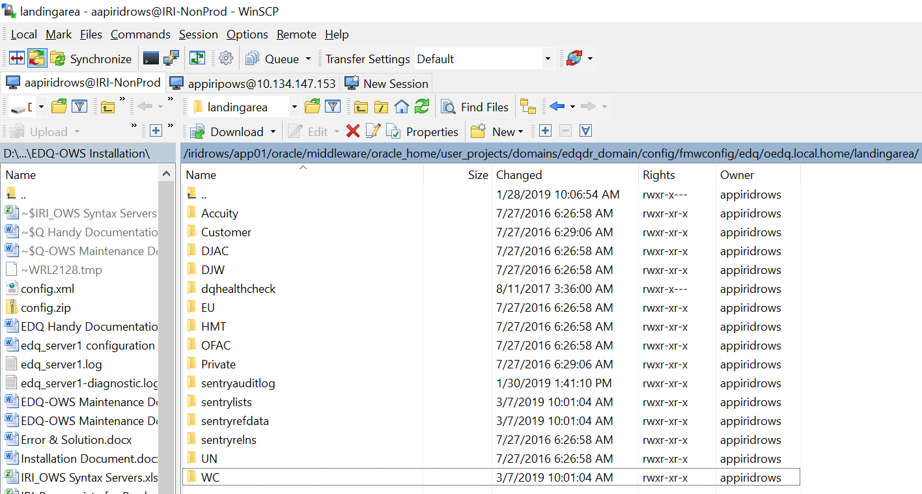

Prod:

/iripows/app01/oracle/middleware/oracle_home/user_projects/domains/edqp_domain/config/fmwconfig/edq/oedq.local.home/landingarea

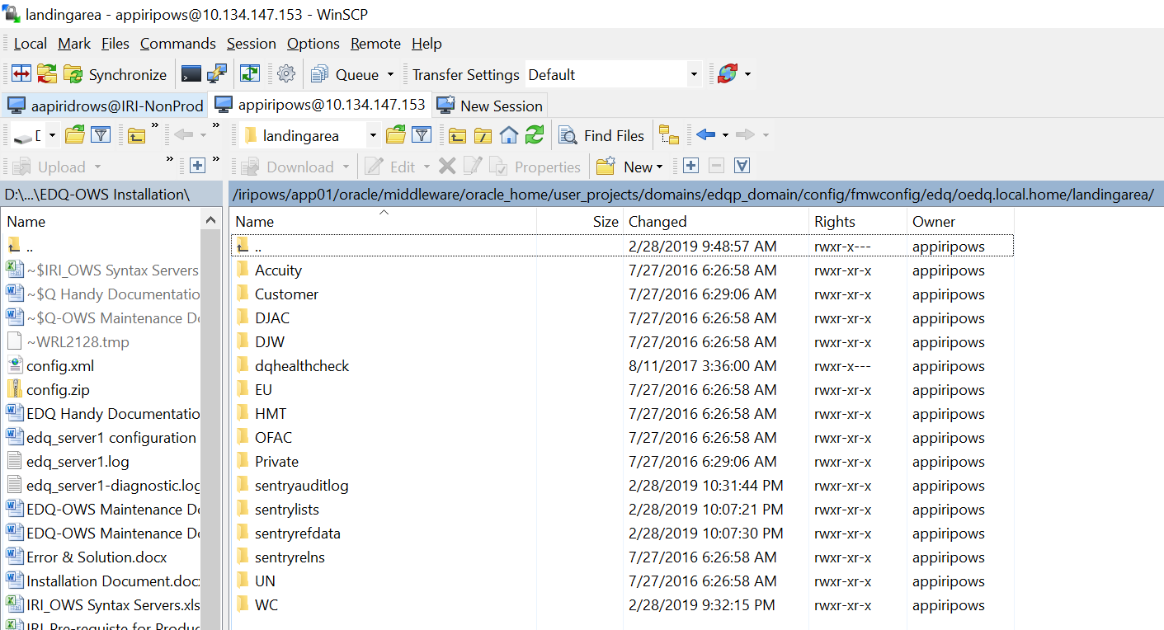

### World Check holding place:

Non-Prod: /iridrows/app01/oracle/middleware/oracle_home/user_projects/domains/edqdr_domain/config/fmwconfig/edq/oedq.local.home/landingarea/WC

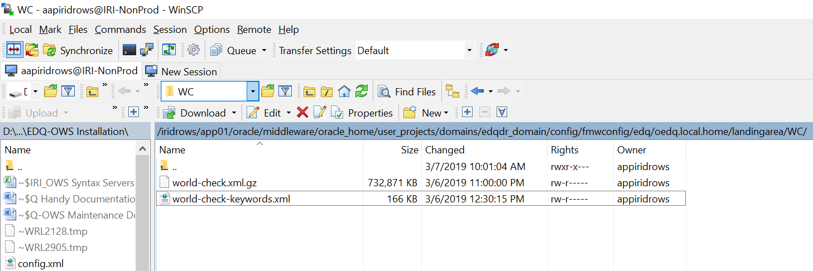

Prod:

/iripows/app01/oracle/middleware/oracle_home/user_projects/domains/edqp_domain/config/fmwconfig/edq/oedq.local.home/landingarea/WC

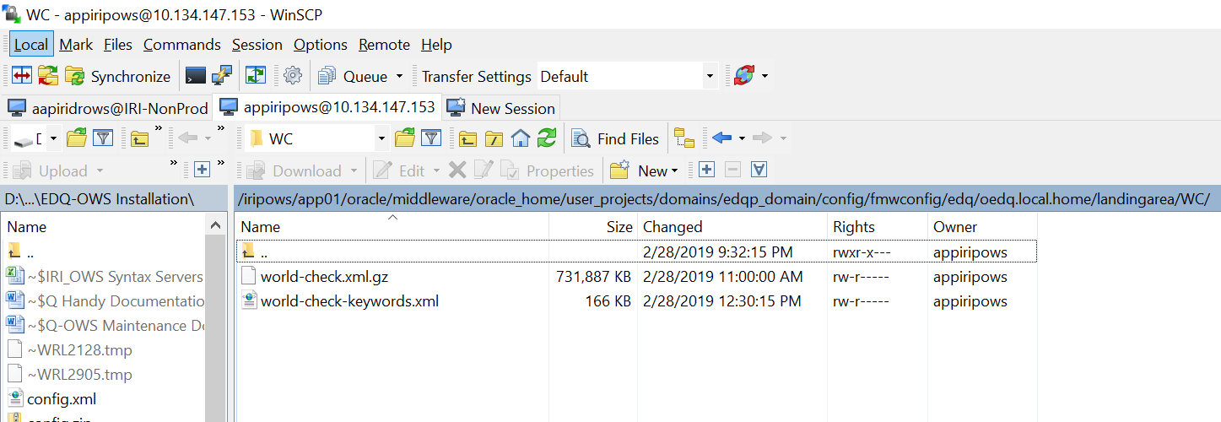

### RUN Profile location:

Non-Prod: /iridrows/app01/oracle/middleware/oracle_home/user_projects/domains/edqdr_domain/config/fmwconfig/edq/oedq.local.home/runprofiles

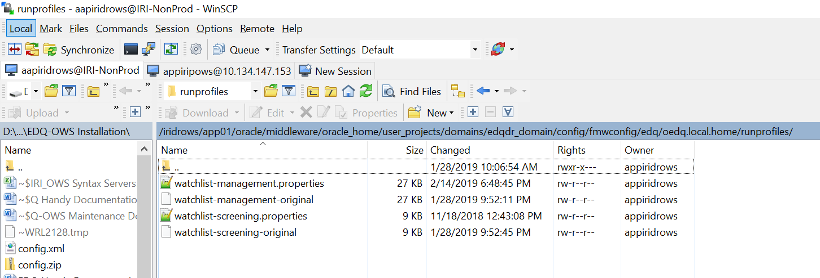

Prod:

/iripows/app01/oracle/middleware/oracle_home/user_projects/domains/edqp_domain/config/fmwconfig/edq/oedq.local.home/runprofiles

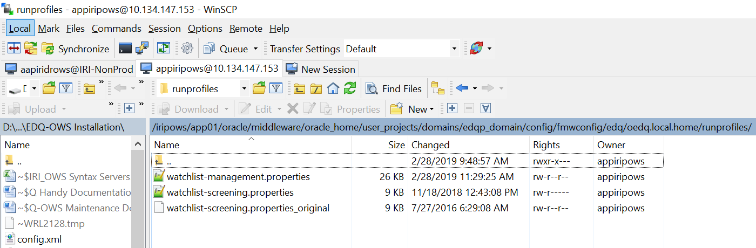

### Run the jobs from Director UI

There are four applications two are primaries (one in non-prod and other one is in prod) and two are secondary application where jobs supposed to run. Please see the system architect below:

#### OWS System Deployment Architect



#### OWS Project Server Layout Reference

| **Instance Name** | **Host Name** | **IP Address** | **Build Due Date (MM/DD/YYYY)** | **Instance Description** | **Instance/Host Type** | **OS Name and Version** | **Cores** | **vCPUs** | **Ram (GB)** | **Data Center Location** | **Time Zone** |
| --- | --- | --- | --- | --- | --- | --- | --- | --- | --- | --- | --- |
| IRIDR | iripsd01.coresys.com | 10.161.147.149 | 2019-01-02 | WebLogic 12c (Primary) | Non-Production | Oracle Linux Server release 6.9 | 6 | 12 | 48 | PDC | EST |
| IRIPROD | iripsp01.coresys.com | 10.134.147.153 | 2019-01-02 | WebLogic 12c (Primary) | Production | Oracle Linux Server release 6.9 | 6 | 12 | 48 | EDC | EST |
| IRIDR | iripsd02.coresys.com | 10.161.147.150 | 2019-01-02 | WebLogic 12c (Secondary) | Non-Production | Oracle Linux Server release 6.9 | 2 | 4 | 16 | PDC | EST |
| IRIDR | iripsd03.coresys.com | 10.161.147.151 | 2019-01-02 | Oracle Enterprise Edition 12c | Non-Production | Oracle Linux Server release 6.9 | 2 | 4 | 16 | PDC | EST |
| IRIPROD | iripsp03.coresys.com | 10.134.147.155 | 2019-01-02 | WebLogic 12c (Secondary) | Production | Oracle Linux Server release 6.9 | 2 | 4 | 16 | EDC | EST |
| IRIPROD | iripsp02.coresys.com | 10.134.147.154 | 2019-01-02 | Oracle Enterprise Edition 12c | Production | Oracle Linux Server release 6.9 | 2 | 4 | 16 | EDC | EST |

#### OWS URLs

The browser URL for all four applications are given below which is tied with load balancer and IRI Domain (<http://iridrows.register-iri.com/edq/faces/home> - Non-Prod) and [http://iriprodows.register-iri.com](https://urldefense.proofpoint.com/v2/url?u=http-3A__iriprodows.register-2Diri.com&d=DwMFaQ&c=RoP1YumCXCgaWHvlZYR8PZh8Bv7qIrMUB65eapI_JnE&r=rXi9QTROMzde2BmRCBJwY2QZ9wIxopeTLcsGSn0JtCc&m=XVFEw8OrymJa8iN8t0RWWpyy4lMlYqjA3kpYDh_-XSs&s=cPlbMjLva_pNhuJvYd80zQ-ar9GgbM15UeeioJQC660&e=) –Prod:

1. <http://10.161.147.149:8001/edq/faces/index.jspx> (Non-Prod Primary)
2. <http://10.161.147.150:8001/edq/faces/index.jspx> (Non-Prod Secondary)
3. <http://10.134.147.153:8001/edq/faces/index.jspx> (Prod Primary)
4. <http://10.134.147.154:8001/edq/faces/index.jspx> (Prod Secondary)

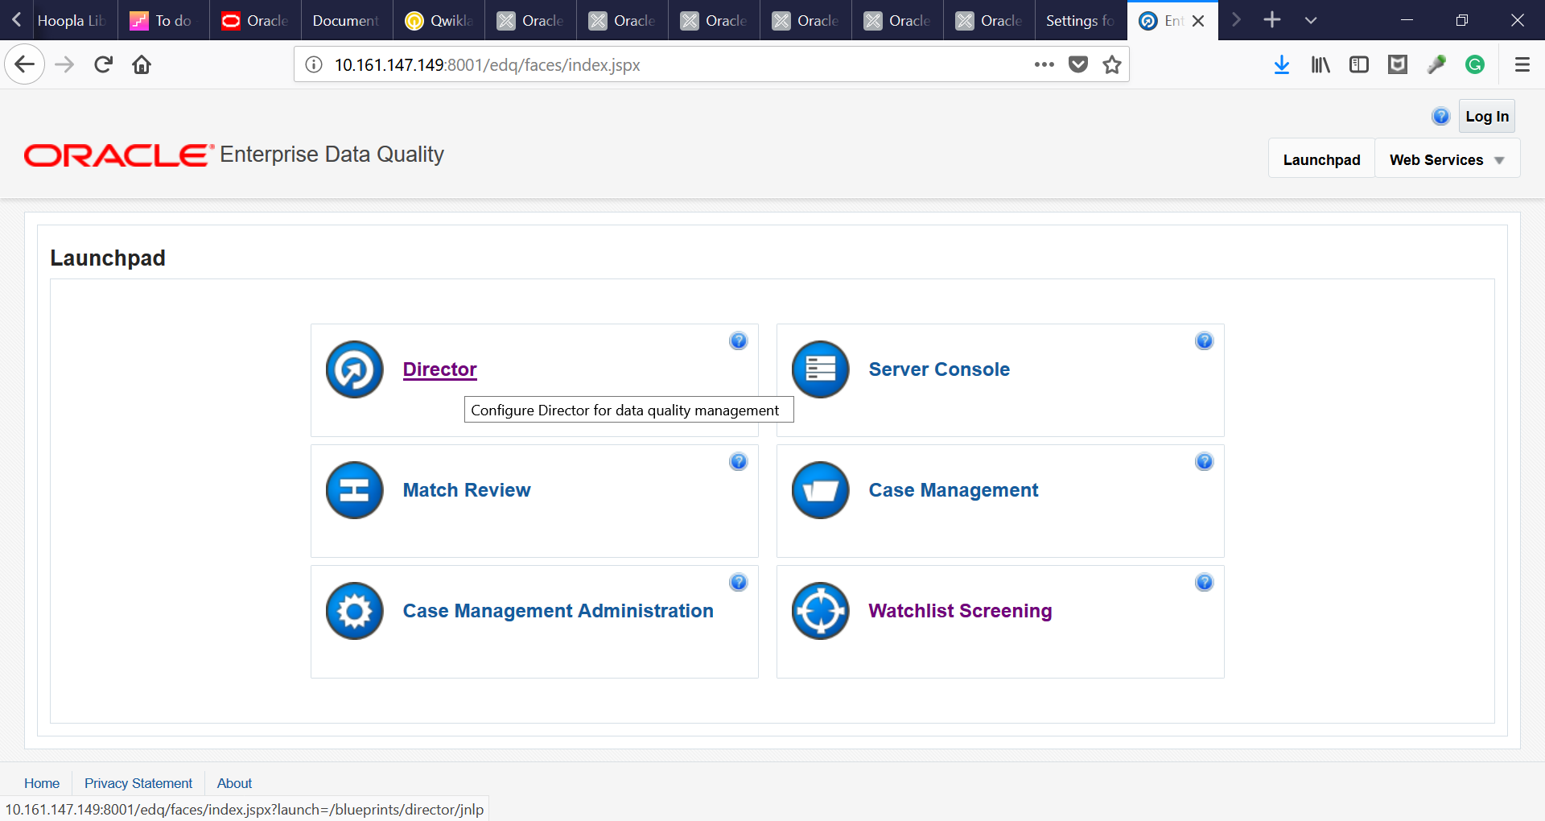

1. Click Director for logging into the Director Application to run the job, and accept the java jnlp.jnpl file

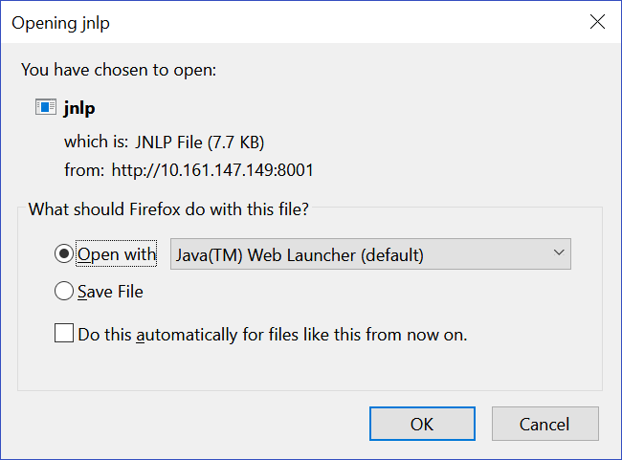

1. Click OK
2. Application will open. Use your own credentials to login into the Director Application;

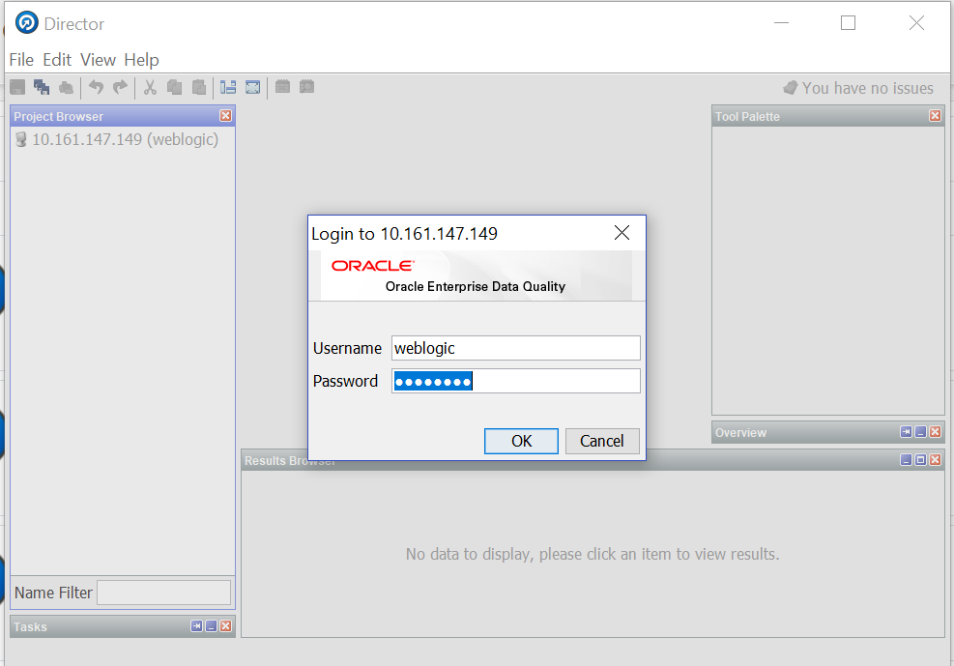

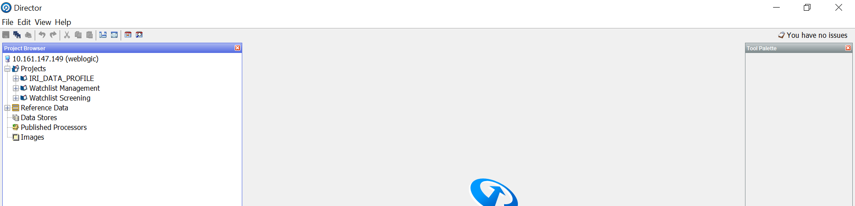

#### To load the reference file WC (World Check)

1. Go to the project “Watchlist Management”
2. Expand the “Jobs” object under Watchlist Management project
3. Right click “Download, Prepare, Filter and Export All Lists” and select “Run with Profile” option
4. Select “Watchlist Management” profile from dropdown menu
5. Click OK
6. It will take 20+ minute to complete the task

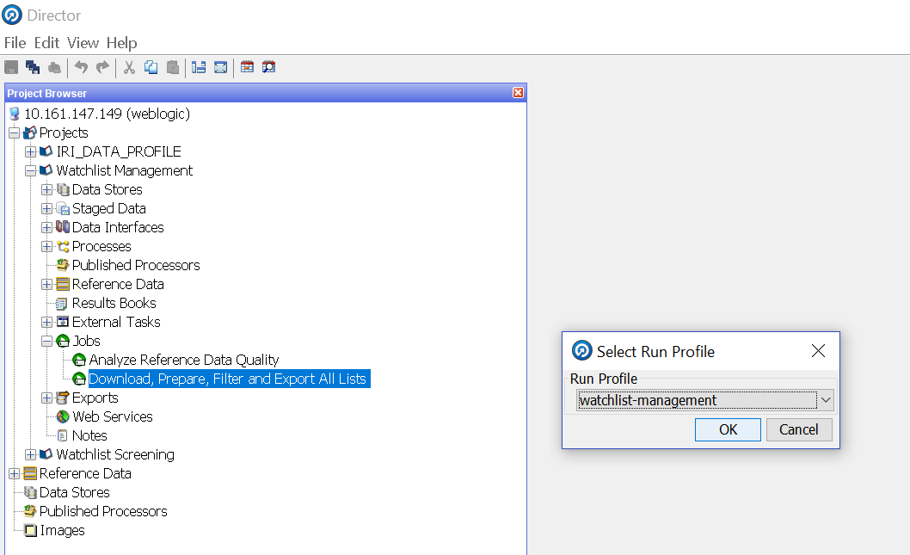

#### To run the real-time job

1. Go to project “Watchlist Screening
2. Expand the “Jobs” object under “Watchlist Screening” project
3. Right click “PART 2 - Prepare Reference Data” and select “Run with Profile” option
4. Select “Watchlist Screening” profile from dropdown menu
5. Click OK
6. It will take 20+ minute to complete the task

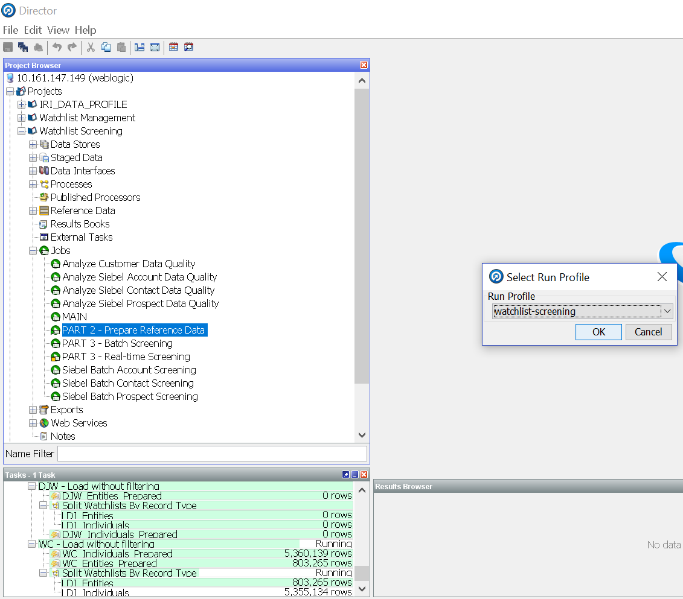

1. Right click “PART 3 - Real-time Screening” and select “Run with Profile” option
2. Select “Watchlist Screening” profile from dropdown menu
3. Click OK
4. It will load all the reference data for customer screening.
5. Within 12minute of the execution, Entity real-time will be ready to screen via web-service
6. Within 20minute of the execution, Individual real-time will be ready to screen customer data via web-service.
7. Make sure the Jobs are running to continue your real-time web service execution.

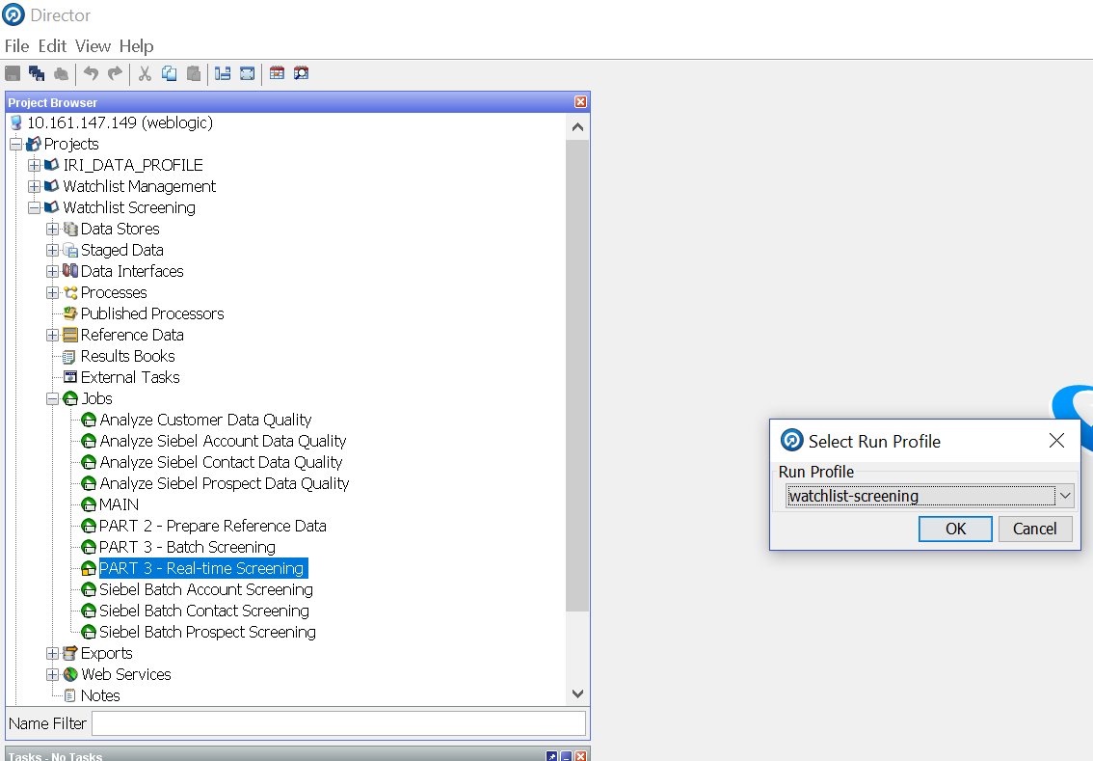

## Log-file location:

### Log-file location to check the log “main0.log”

Non-Prod: /iridrows/app01/oracle/middleware/oracle_home/user_projects/domains/edqdr_domain/servers/AdminServer/logs/edq/logs

Prod:

/iripows/app01/oracle/middleware/oracle_home/user_projects/domains/edqp_domain/servers/AdminServer/logs/edq/logs

### Log-file location to check the log “edq_server1-diagnostic.log” & “edq_server1.log”

Non-Prod:

/iridrows/app01/oracle/middleware/oracle_home/user_projects/domains/edqdr_domain/servers/edq_server1/logs

Prod:

/iripows/app01/oracle/middleware/oracle_home/user_projects/domains/edqp_domain/servers/edq_server1/logs

### Install file location:

Non-Prod:

/iridrows/app01/media

Prod:

/iripows/app01/media

### EDQ Local home location:

Non-Prod:

/iridrows/app01/oracle/middleware/oracle_home/user_projects/domains/edqdr_domain/config/fmwconfig/edq/oedq.local.home

Prod:

/iripows/app01/oracle/middleware/oracle_home/user_projects/domains/edqp_domain/config/fmwconfig/edq/oedq.local.home

## Delete the Alerts from Watchlist Screening UI

1. Login to the Watchlist Screening UI
2. Click the Case Management Tab on top
3. Click on Filter on the below to search for the case/alerts
4. Select Type = Alerts and click the green button on the below page 
5. Select all the records with ctrl a and click Bulk Delete from top. Please see the screen shot below:

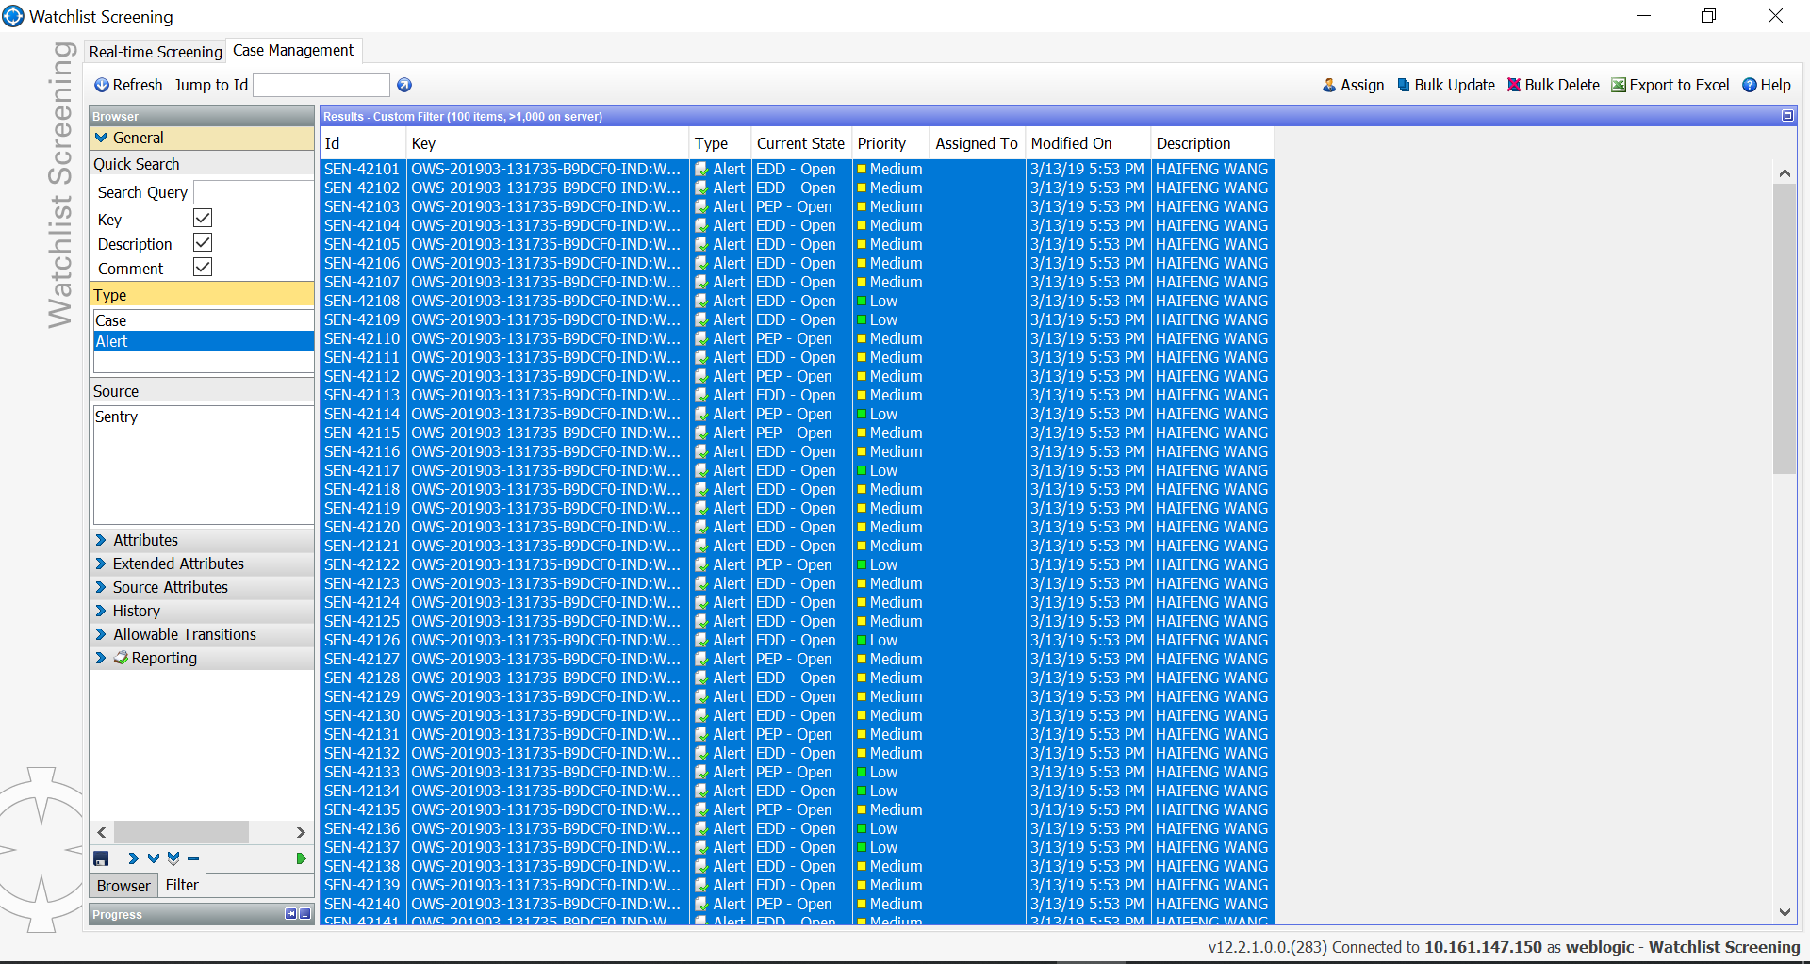

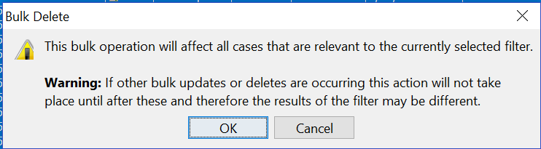

1. Click OK

### Error Log:

#### Error while initiating the download of WC data:

[2019-02-20T22:53:48.229-05:00] [edq_server1] [ERROR] [EDQ-06919] [oracle.edq.main] [tid: Mission Executor Work Unit Thread [2-2]] [userId: <anonymous>] [ecid: b023fea8-abf5-4bc0-a3ce-8f4231d3ac70-00003116,0:63093:27:2] [APP: edq] [partition-name: DOMAIN] [tenant-name: GLOBAL] [process WC Preparation [43]/job:Download, Prepare, Filter and Export All Lists (2):[12]] : runtime process terminated uncleanly: Could not open resource "WC Profile From UID" (Code: 201,063)

##### Solution:

##### The error comes for very first time and it will not repeat as the data will always be there. Make sure that you run “WC_Profiles” staging and then rerun the “Download, Prepare, Filter and Export All Lists” with “Run with profile” and select watchlist-management.

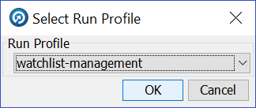

#### Tablespace Error:

* 1. 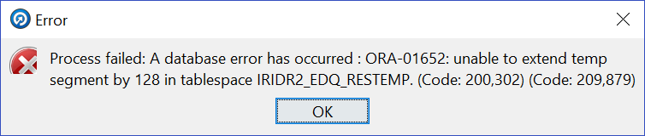

Caused by: Error : 1652, Position : 500, Sql = SELECT dn_t49.record_id, dn_t49.coded_value, dn_t49.cluster_index, dn_t49.hash_value, dn_t49.director_id, dn_t49.ident0, dn_t49.ident1, dn_t49.ident2, dn_t49.ident3, dn_t49.ident4, dn_t49.ident5, dn_t49.ident6, dn_t49.ident7, dn_t49.ident8, dn_t49.ident9, dn_t49.ident10, dn_t49.ident11, dn_t49.ident12, dn_t49.ident13, dn_t49.ident14, dn_t49.ident15, dn_t49.ident16, dn_t49.ident17, dn_t49.ident18, dn_t49.ident19, dn_t49.ident20, dn_t49.ident21, dn_t49.ident22, dn_t49.ident23, dn_t49.ident24 FROM dn_t49 ORDER BY dn_t49.coded_value, OriginalSql = SELECT dn_t49.record_id, dn_t49.coded_value, dn_t49.cluster_index, dn_t49.hash_value, dn_t49.director_id, dn_t49.ident0, dn_t49.ident1, dn_t49.ident2, dn_t49.ident3, dn_t49.ident4, dn_t49.ident5, dn_t49.ident6, dn_t49.ident7, dn_t49.ident8, dn_t49.ident9, dn_t49.ident10, dn_t49.ident11, dn_t49.ident12, dn_t49.ident13, dn_t49.ident14, dn_t49.ident15, dn_t49.ident16, dn_t49.ident17, dn_t49.ident18, dn_t49.ident19, dn_t49.ident20, dn_t49.ident21, dn_t49.ident22, dn_t49.ident23, dn_t49.ident24 FROM dn_t49 ORDER BY dn_t49.coded_value, Error Msg = ORA-01652: unable to extend temp segment by 128 in tablespace IRIDR2_EDQ_RESTEMP   at oracle.jdbc.driver.T4CTTIoer11.processError(T4CTTIoer11.java:499)      ... 24 more

##### Solution:

Extend the tables:

<server>

<name>edq_server1</name>

<reverse-dns-allowed>false</reverse-dns-allowed>

<native-io-enabled>true</native-io-enabled>

<ssl>

<name>edq_server1</name>

<hostname-verifier xsi:nil="true"></hostname-verifier>

<hostname-verification-ignored>true</hostname-verification-ignored>

<export-key-lifespan>500</export-key-lifespan>

<client-certificate-enforced>false</client-certificate-enforced>

<login-timeout-millis>25000</login-timeout-millis>

<two-way-ssl-enabled>false</two-way-ssl-enabled>

<ssl-rejection-logging-enabled>true</ssl-rejection-logging-enabled>

<inbound-certificate-validation>BuiltinSSLValidationOnly</inbound-certificate-validation>

<outbound-certificate-validation>BuiltinSSLValidationOnly</outbound-certificate-validation>

<allow-unencrypted-null-cipher>false</allow-unencrypted-null-cipher>

<use-server-certs>false</use-server-certs>

</ssl>

<max-open-sock-count>-1</max-open-sock-count>

<stuck-thread-max-time>3600</stuck-thread-max-time>

<stuck-thread-timer-interval>60</stuck-thread-timer-interval>

<gathered-writes-enabled>false</gathered-writes-enabled>

<scattered-reads-enabled>false</scattered-reads-enabled>

<machine>edqdr_machine1</machine>

<listen-port>8001</listen-port>